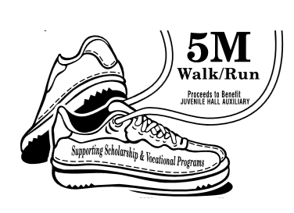

WALK PARTICIPATION
REGISTRATION

EVENT INFORMATION

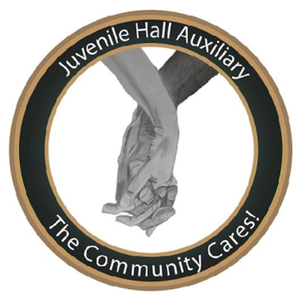
EVENT INFORMATION
CHIEF PHILIP KADER WALK – GIVING YOUTH A SECOND CHANCE
Date: Saturday October 11th, 2014
Time: 10:00am-2:00pm, Finish Line Party Included
Location: Lafayette Reservoir, 3849 Mt. Diablo Blvd. Lafayette, CA
----------------------------------------------------------------------------------------------------------------------------------------------------------

LAST NAME: ____________________________________ FIRST NAME: _______________________________
EMAIL: ________________________________________ PHONE NUMBER: ___________________________
STREET ADDRESS: ________________________________ CITY: ____________________ STATE: __________
ZIP: _________________ T-Shirt Size: _S M_L_XL_____
EMERGENCY CONTACT: __________________________ _ RELATIONSHIP: _______________________________
PHONE NUMBER: _____________________________

If you are Walking, Please Review and $√$ Box to the right & Submit.
---------------------------------------------------------------------------------------------------------------------------------------------------------------- ASSIGNMENTS
If you are helping out in Other Areas, please see areas of participation below. You will be notified via e-mail regarding your areas of choice. Please select 3. 1- Community Advertisement and/or Flyers 2- Orientation or Wrap Up Meeting 3- Set-Up 4- Registration/Check in Table 5- Hand Out Water/Snacks 6- Clean Up 7- Follow Up 8- Other
1st CHOICE:
2nd CHOICE:
3rd CHOICE:
----------------------------------------------------------------------------------------------------------------------------------------------------------------
SUPPLIES
T-Shirts and Water will be provided. We are still in need of items listed below. Please $√$ box next to any item(s) you can loan or donate. You will be contacted via e-mail regarding availability.
AVAILABLE SUPPLIES:
tables canopy trash bags chairs
snacks medical kit Other________________
All proceeds benefit the Juvenile Hall Auxiliary of Contra Costa County 501(c)(3) non-profit.
Please visit us at our Website: WWW.REACHINGOURYOUTH.ORG
Thank You for Helping us Give Youth a Second Chance Through our Scholarship and Vocational Training Programs.

